# **Data + Reading resources (ranked from most relevant to least)**

1. <https://www.datasetlist.com/>
2. <https://www.g2.com/categories/data-labeling>
3. <https://www.xailient.com/post/image-data-labelling-and-annotation> (types of image annotation format)
4. <https://lionbridge.ai/articles/image-annotation-tools-for-computer-vision/>
5. <https://www.datasetlist.com/tools/>
6. <https://github.com/jsbroks/awesome-dataset-tools>
7. <https://www.sicara.ai/blog/2019-09-01-top-five-open-source-annotation-tools-computer-vision>
8. <https://hackernoon.com/the-best-image-annotation-platforms-for-computer-vision-an-honest-review-of-each-dac7f565fea>
9. <https://robocup.informatik.uni-hamburg.de/wp-content/uploads/2017/11/imagetagger-poster.pdf>
10. <https://github.com/microsoft/VoTT#labeling-a-video>
11. <https://medium.com/@deepsystems/supervisely-november-release-reimagine-image-annotation-and-data-science-workflows-4485de604fd9>
    1. But on their website, it says coming soon and the sales representative says the business version is in “soft launch”

Sources

<https://www.datasetlist.com/>

<https://github.com/jsbroks/awesome-dataset-tools>

# **Criteria**

**Main consideration**

1. **SaaS**
2. **Server-sided data**
3. **User-isolation** 
   1. **Data - isolation**
4. **YOLO format**
5. **Pre-detect using built-in model**
6. **Checking**
7. **Host 10K+ pictures**
8. **Analytics**
9. **Features**

[**https://www.snorkel.org/features/**](https://www.snorkel.org/features/) **- to be reviewed (18/2/2021)**

# Shortlisted open source labelling tools

## LOST (324 star) (2019) (MIT) *

### **Description**

Not sure if it supports YOLO format. Export as CSV

LOST (Label Object and Save Time) is a flexible **web-based framework** for semi-automatic image annotation. It provides multiple annotation interfaces for fast image annotation. LOST is flexible since it allows to run user defined annotation pipelines where different annotation interfaces/ tools and algorithms can be combined in one process. It is web-based since the whole annotation process is visualized in your browser. You can quickly setup LOST with docker on your local machine or run it on a web server to make an annotation process available to your annotators around the world. LOST allows to organize label trees, to monitor the state of an annotation process and to do annotations inside the browser. LOST was especially designed to model semi-automatic annotation pipelines to speed up the annotation process. Such a semi-automatic can be achieved by using AI generated annotation proposals that are presented to an annotator inside the annotation tool.

Research paper: <https://arxiv.org/abs/1910.07486>

Documentation: <https://lost.readthedocs.io/en/latest/>

### Source: <https://github.com/l3p-cv/lost>

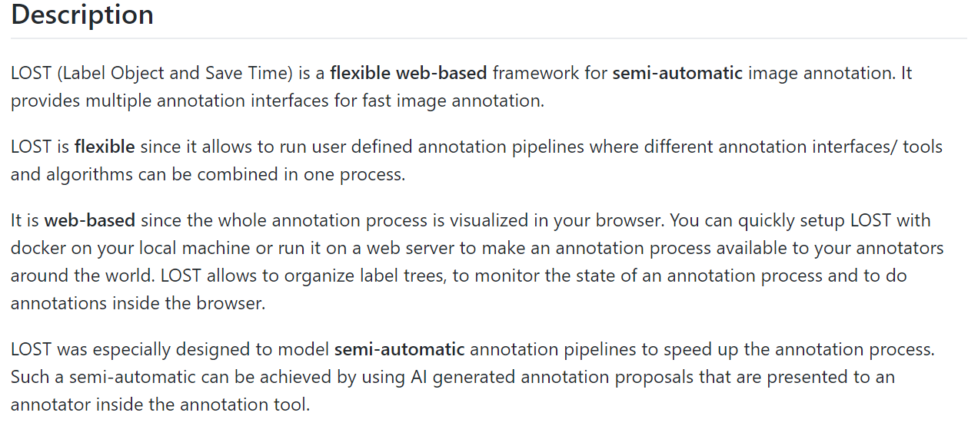

### **Users, groups and roles**

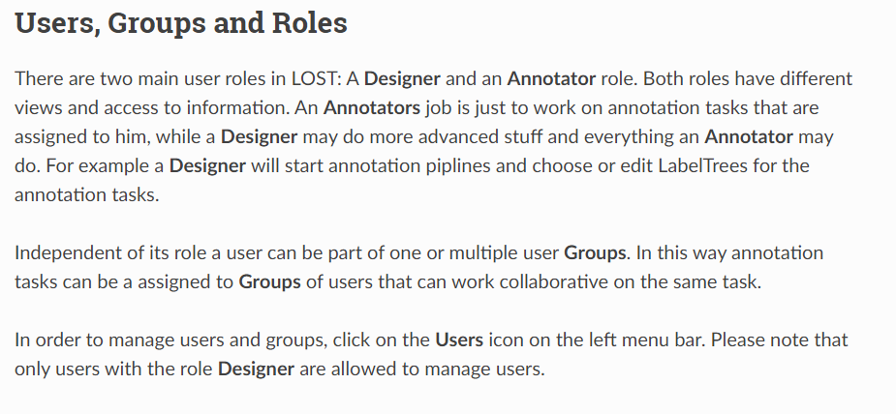

### Standard setup

have to install docker and WSL2, and make sure WSL2 is enabled in Docker settings

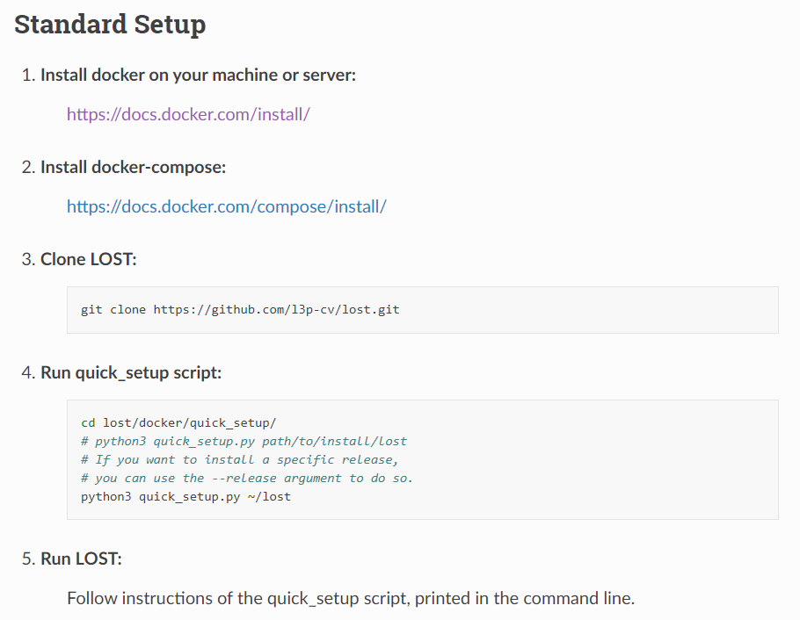

LOST is running in my web browser using localhost, docker

**Main consideration**

1. **SaaS**
2. **Server-sided data**
3. **User-isolation** 
   1. **Data isolation (code configured)**
4. **~~YOLO format~~**
5. **Pre-detect using built-in model**
6. **Checking**
7. **Analytics**

**Script and developer friendly**

## Universal Data Tool (807 stars) (2019) (MIT) *

### Description:

The Universal Data Tool (UDT) is an open-source web or downloadable tool for labelling data for usage in machine learning or data processing systems. The Universal Data Tool supports Computer Vision, Natural Language Processing (including Named Entity Recognition and Audio Transcription) workflows.

### Source: <https://universaldatatool.com/> , <https://github.com/UniversalDataTool/universal-data-tool>

### Users, groups and roles

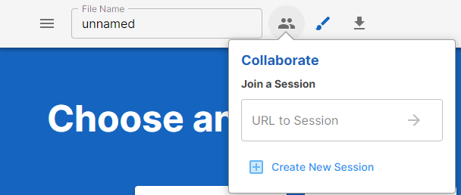

### Standard setup

Download (<https://github.com/UniversalDataTool/universal-data-tool/releases>)

.exe or applmage file

Downloaded the .exe file, something wrong with the .exe file

**Main consideration**

1. **SaaS**
2. **~~Server-sided data~~**
3. **~~User-isolation~~** 
   1. **~~Data isolation~~**
4. **~~YOLO format~~**
5. **~~Pre-detect using built-in model~~**
6. **~~Checking~~**
7. **~~Analytics~~**

**\*a lot of labelling features**

## CVAT (3.6k) (2018) (MIT) (y)👍

### Description

On the demo website, it says YOLOv1.1 (<https://cvat.org/tasks/6182>)

e.g. 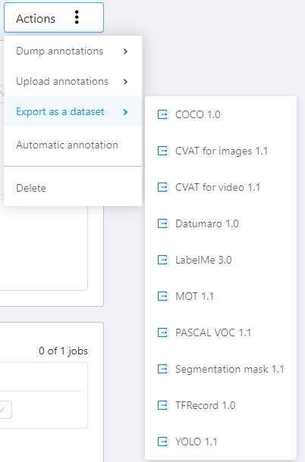

CVAT is completely re-designed and re-implemented version of Video Annotation Tool from Irvine, California tool. It is free, online, interactive video and image annotation tool for computer vision. It is being used by our team to annotate million of objects with different properties. Many UI and UX decisions are based on feedbacks from professional data annotation team.

### Source:

<https://github.com/opencv/cvat>

### users, groups and roles

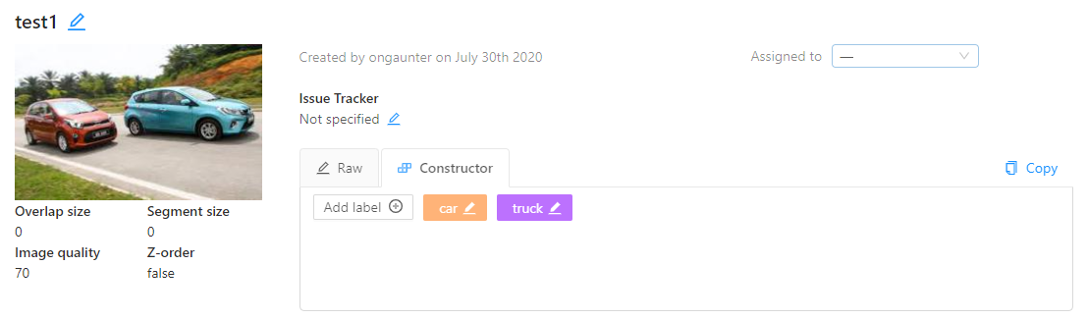

### standard setup:

use WSL2 and docker (check source)

**Main consideration**

1. **SaaS**
2. **Server-sided data**
3. **User-isolation** 
   1. **Data isolation**
4. **YOLO format 1.1**
5. **Pre-detect using built-in model**
6. **Checking**
7. **Analytics**

## Scalabel (352) (2018) (BSD) (y)👍

### Description

FORMAT: JSON or YAML

A scalable open-sourced annotation web tool brought by Berkeley DeepDrive. Support various types of annotations on both images and videos Build innovative features and user-friendly interface Improve speed by using semi-automated annotations Support concurrent annotation sessions and progress monitoring Accessible through a web browser without installation.

Bounding boxes

<https://www.scalabel.ai/doc/2d-bb.html>

### Source: <https://github.com/scalabel/scalabel>

Documentation: <https://www.scalabel.ai/doc/>

### Users, groups and roles

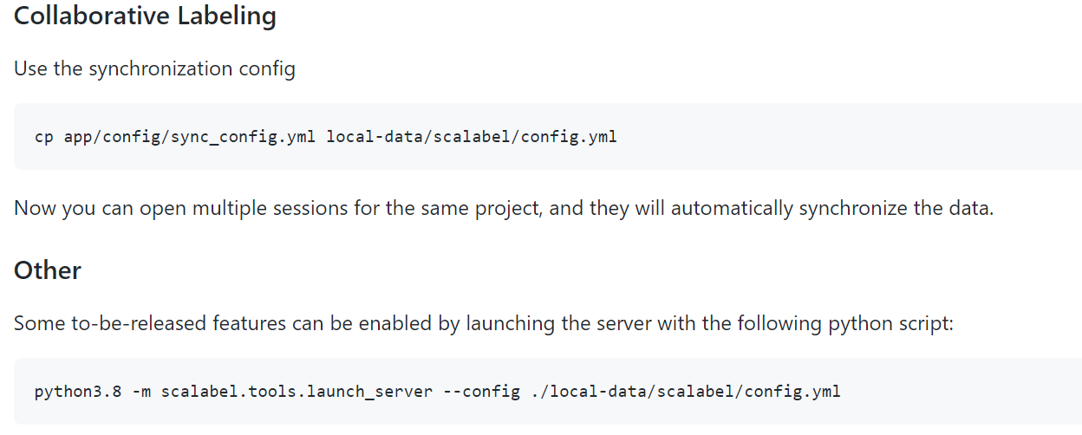

<https://www.scalabel.ai/doc/user-management.html>

### Standard setup

Wsl2 and DOCKER (refer to source)

**Main consideration**

1. **SaaS**
2. **Server-sided data**
3. **User-isolation** 
   1. **Data isolation**
4. **~~YOLO format 1.1~~**
5. **~~Pre-detect using built-in model~~**
6. **~~Checking~~**
7. **~~Analytics~~**

**Script to split frames**

**Useful for autonomous driving, has interpolation**

# Labelling software (open source)

## **SMART (99 stars) (2017) (MIT)**

### Description

SMART is an open source application designed to help data scientists and research teams efficiently build labeled training datasets for supervised machine learning tasks.

**Only capable of doing this**

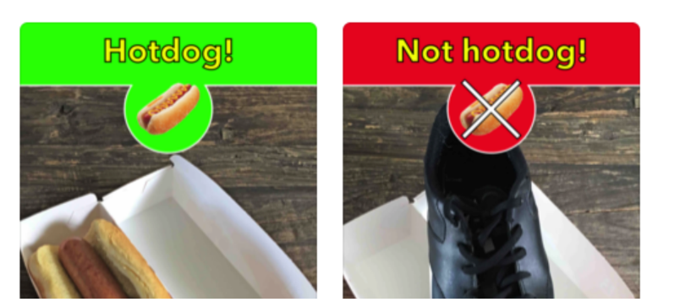

It’s like a pirated version of LOST

### Source: <https://github.com/RTIInternational/SMART>

### Users, groups and roles

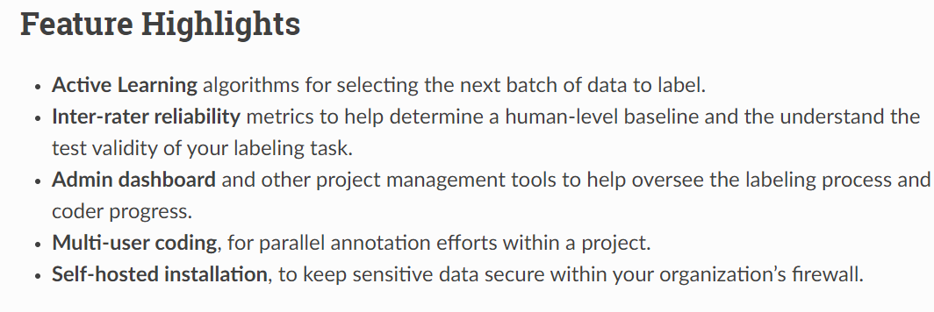

### Standard setup

Using docker

## Maksense.ai (1.2k star) (2019) (GPL)

### Description

Supports YOLO format

A free and open source tool that aims to significantly reduce the time of labeling in object detection projects. No installation is required, all you need is a browser. Make Sense is online, but we care about your privacy and we don't send your photos anywhere.

### Source: <https://www.makesense.ai/>

A free and open source tool that aims to significantly reduce the time of labeling in object detection projects. No installation is required, all you need is a browser. Make Sense is online, but we care about your privacy and we don't send your photos anywhere.

### Users, groups and roles

Not possible

### Standard setup

Web based

Tested and uploaded 1300 images onto makeSense.ai

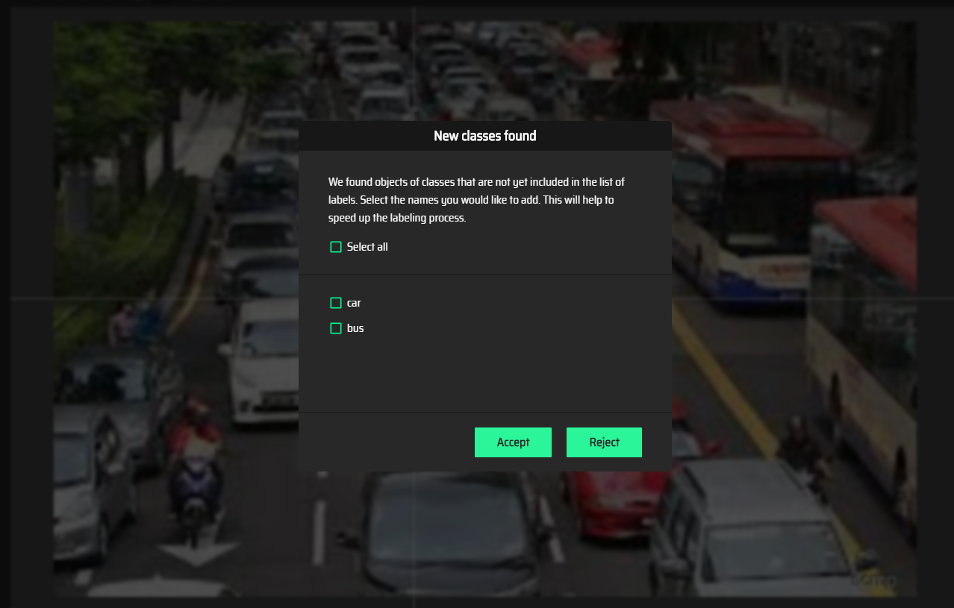

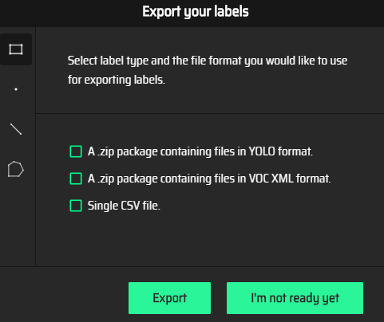

## LabelImg (11.3k stars) (2015) (MIT)

### Description

Supports YOLO format

### Source: <https://github.com/tzutalin/labelImg>

LabelImg is a graphical image annotation tool. It is written in Python and uses Qt for its graphical interface. Annotations are saved as XML files in PASCAL VOC format, the format used by ImageNet.

### Users, groups and roles

Not possible

### Standard setup

easy

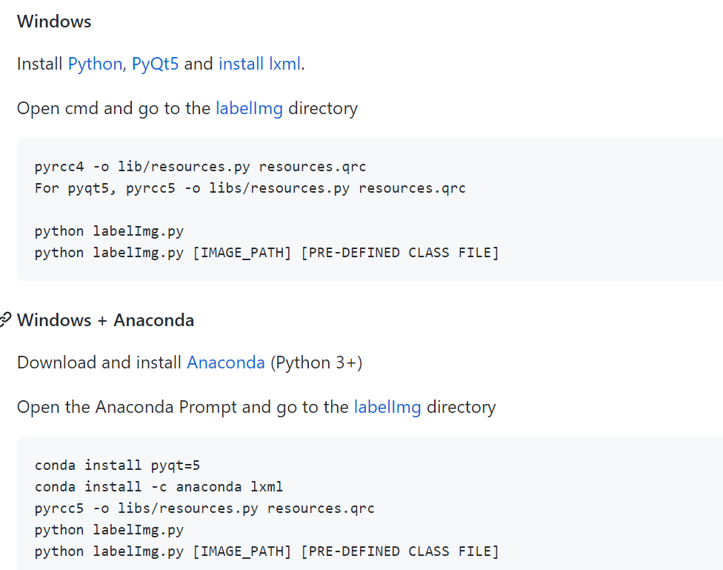

## Labelme (5k stars) (2011) (GPL)

### Description

Supports JSON format, but can convert (reference: <https://github.com/wkentaro/labelme/issues/650>)

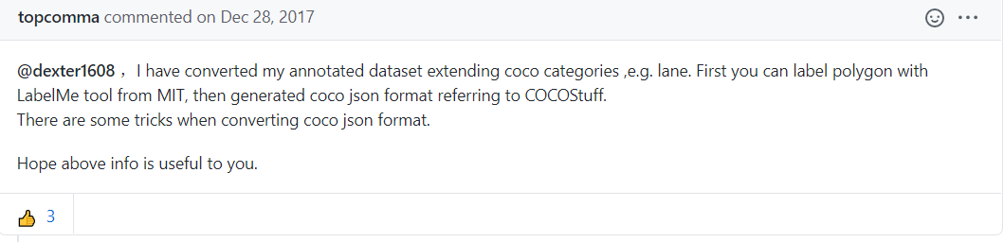

### Source: <https://github.com/wkentaro/labelme>

Labelme is a graphical image annotation tool inspired by http://labelme.csail.mit.edu. It is written in Python and uses Qt for its graphical interface.

### Users, groups and roles

Not possible

### Standard setup

Very easy

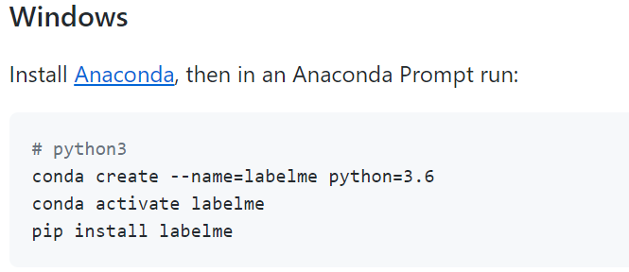

To run, go anaconda cmd and type labelme

## Microsoft VOTT (2.7k stars) (2017) (MIT)

### Description

Does not support YOLO format, supports

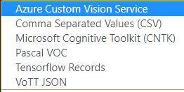

An open source annotation and labeling tool for image and video assets. VoTT is a React + Redux Web application, written in TypeScript. This project was bootstrapped with Create React App. Features include: The ability to label images or video frames Extensible model for importing data from local or cloud storage providers Extensible model for exporting labeled data to local or cloud storage providers VoTT helps facilitate an end-to-end machine learning pipeline.

### Source:

<https://github.com/microsoft/VoTT>

### Users, groups and roles

Give specific connection to specific freelancers

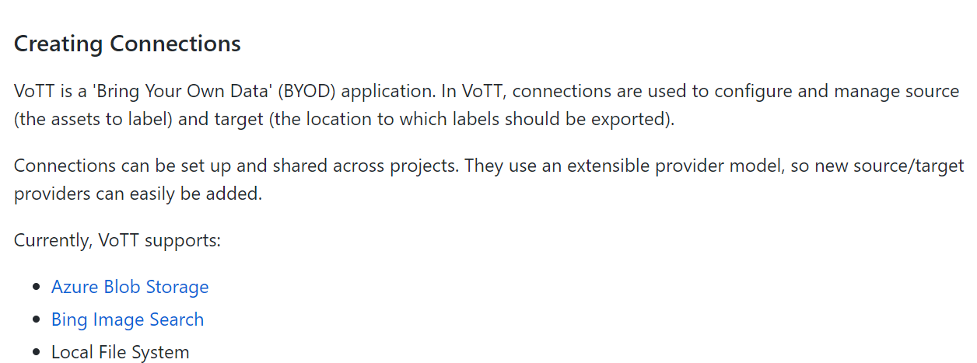

### Standard setup

<https://github.com/Microsoft/VoTT/releases>

Open VoTT exe in folder

## YOLO BBOX annotation tool (123) (2018) (MIT)

### Description:

Fast and efficient BBox annotation for your images in YOLO, and now, VOC/COCO formats!

### Source: <https://github.com/drainingsun/ybat>

### Users, groups and roles

Not possible

### Standard setup

DEMO



## COCO annotator tool (802) (2018) (MIT)

### Description:

Supports JSON

COCO Annotator is a web-based image annotation tool designed for versatility and efficiently label images to create training data for image localization and object detection. It provides many distinct features including the ability to label an image segment (or part of a segment), track object instances, labelling objects with disconnected visible parts, efficiently storing and export annotations in the well-known COCO format. The annotation process is delivered through an intuitive and customizable interface and provides many tools for creating accurate datasets.

Demo WEBSITE DOWN

### source: <https://github.com/jsbroks/coco-annotator>

### Users, groups and roles

Not supported

### Standard setup:

Use docker to install

<https://www.youtube.com/watch?feature=player_embedded&v=OMJRcjnMMok>

## Polygon RNN+ (648 stars) (2018) (N/A)

### Description

This is the official PyTorch reimplementation of Polygon-RNN++ (CVPR 2018).

### Source : <http://www.cs.toronto.edu/~amlan/demo/>

Not suitable

## Pixel annotator tool (810 stars) (2017) (LGPL)

### Description

Software that allows you to manually and quickly annotate images in directories. The method is pseudo manual because it uses the algorithm watershed marked of OpenCV. The general idea is to manually provide the marker with brushes and then to launch the algorithm.

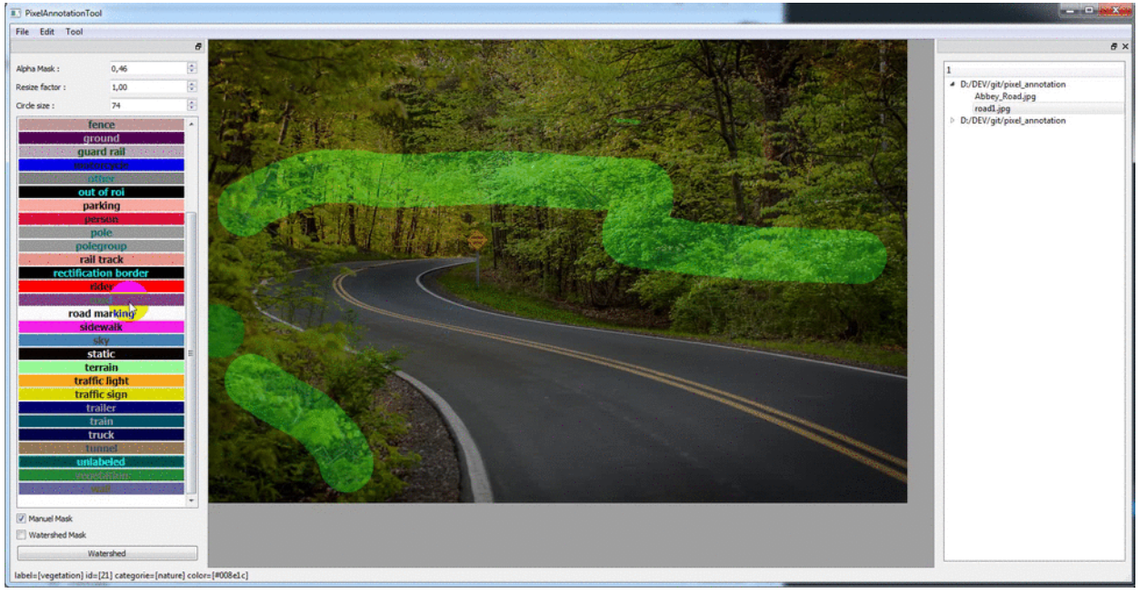

Not suitable

### Source: <https://github.com/abreheret/PixelAnnotationTool>

## FIAT (893) (2017) (GPL)

### Description:

FIAT enables image data annotation, data augmentation, data extraction, and result visualisation/validation. Annotate images for image classification, optical character reading (digit classification, letter classification), ... Extract data into different format (Caffe LMDB, OpenCV Cascade Classifiers, Tesseract ... ) with data augmentation (resizing, noise in translation / rotation / scaling, pepper noise , gaussian noise, rectangle merging, line extraction ...).

### Source:

<https://github.com/christopher5106/FastAnnotationTool>

### Users, groups and roles

Lack of documentation and instruction on github. Nothing about YOLO, server based etc

## Deeplabel (68) (2018)

Description:

DeepLabel is a cross-platform tool for annotating images with labelled bounding boxes. A typical use-case for the program is labelling ground truth data for object-detection machine learning applications. DeepLabel runs as a standalone app and compiles on Windows, Linux and Mac.

### Source: <https://github.com/jveitchmichaelis/deeplabel>

### Users, groups and roles

Not possible

### Standard setup

Windows search Deeplabel.exe

## Turkey

### Description:

An Amazon Mechanical Turk turn-key segment tool. Turkey lets you easily **create a web U**I on Amazon Mechanical Turk to **crowd-source** image annotation data. Its main functions include: Customize the annotation modes and class labels on per-image basis, import previous annotations generated by either another human or an algorithm, Zoom-in, zoom-out, delete, undo, reset.

### Resource:

<https://github.com/yanfengliu/turkey/blob/master/MTurk.html>

not suitable

access demo via



## **LabelID (123) (2016)**

### Source: <https://github.com/sweppner/labeld>

Not suitable and no updates since 4 years ago

## **js-segment annotator tool (452) (2013)**

### source: <https://github.com/kyamagu/js-segment-annotator>

old and no updates

## **Sloth (573) (2010)**

### Source: <https://github.com/cvhciKIT/sloth>

Old and no updates

## **VGG image annotator**

### Source: <http://www.robots.ox.ac.uk/~vgg/software/via/>

Not suitable

## **MUVIlab**

### Source: <https://github.com/ale152/muvilab>

Not suitable

## **Comma colouring**

### Source: <https://github.com/commaai/commacoloring>

Not suitable

## **VIAME**

### Description

VIAME is a computer vision application designed for DIY AI including object detection, object tracking, image mosaic, stereo measurement, image/video search, image/video annotation, rapid model generation, and tools for the evaluation of different algorithms. Originally targetting marine species analytics, it now contains many common algorithms and libraries, and is also useful as a generic computer vision library.

Not suitable

### Source: <https://github.com/VIAME/VIAME>

## 6D annotator (6) (2019)

### Description:

This is a tool used to create 6D labels for 2D images. 6D labelling means that a 3D object is fitted onto it's projection in a 2D picture. It is 6D, because the 3D bounding box fitting requires 3 translational inputs (x,y,z) and 3 rotational degrees. It is designed to create labels for singleshotpose and betapose. But should be easily extendable to other 6D label formats.

Not suitable

### Source: <http://annotate.photo/>

LableFlow (marketed as open source, but not really open source)

Free version 🡪 100 images/month

Maskrcnn-custom

<https://github.com/michhar/maskrcnn-custom>

# Labelling software (Commercial)

* Many of the commercialized software don’t provide free demo, need to contact them directly for demo

## Trainingset.ai (not on github)

### Description

Not sure if it supports YOLO format – in the process of asking

### Source: <https://trainingset.ai/>

Our Dashboard and API gives you access to human-powered data & annotations for many use-cases over images, video and text: Box, Lines, Point, Polygon, Segmentation, Cuboid, Text Entity Recognition, Text Classification, Document Data extraction

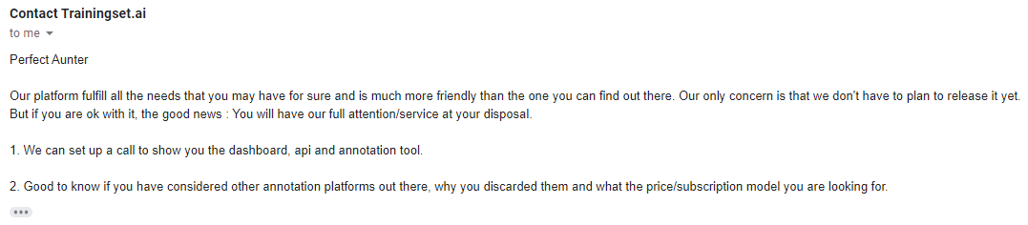

### Users, groups and roles

Possible – but they have no plans to release the software yet

### Standard setup

Don’t know yet, setup call? Or ask them record video and attached as a Gdrive link and share

**Main consideration**

1. **SaaS**
2. **Server-sided data**
3. **User-isolation** 
   1. **Data isolation**
4. **YOLO format 1.1**
5. **Pre-detect using built-in model**
6. **Checking**
7. **Analytics**

## datagym.ai

### source: <https://www.datagym.ai/>

### pricing:

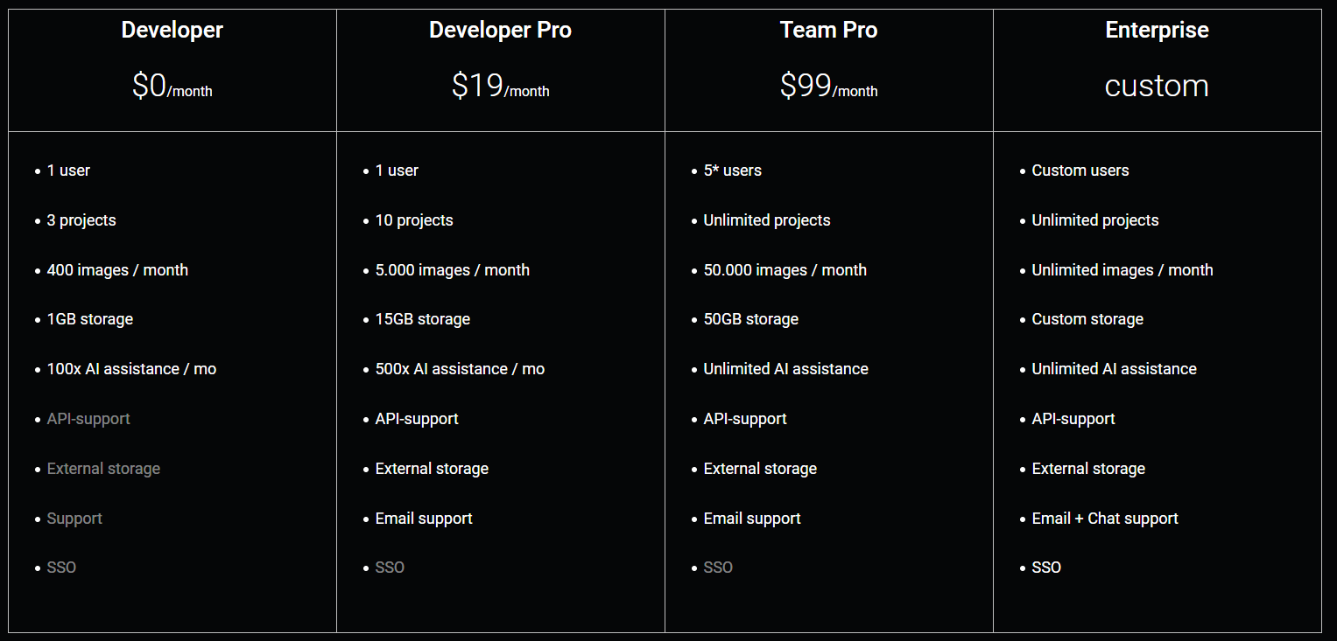

## **Rectlabel**

### Description

An image annotation tool to label images for bounding box object detection and segmentation.

Available for mac os x only

## **TaQadam**

### Description

Format supported

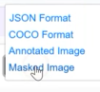

TaQadam is an end-to-end platform to manage training data for Computer Vision models. Bring agility to your data training pipeline. Subscription free, pay for annotations only. Sort, filter and manage pipeline with active learning tools and an API. Trained, dedicated labeling team for your use case, with available communication channels and feedback loops. Custom annotation tools to allow precise semantic segmentation.

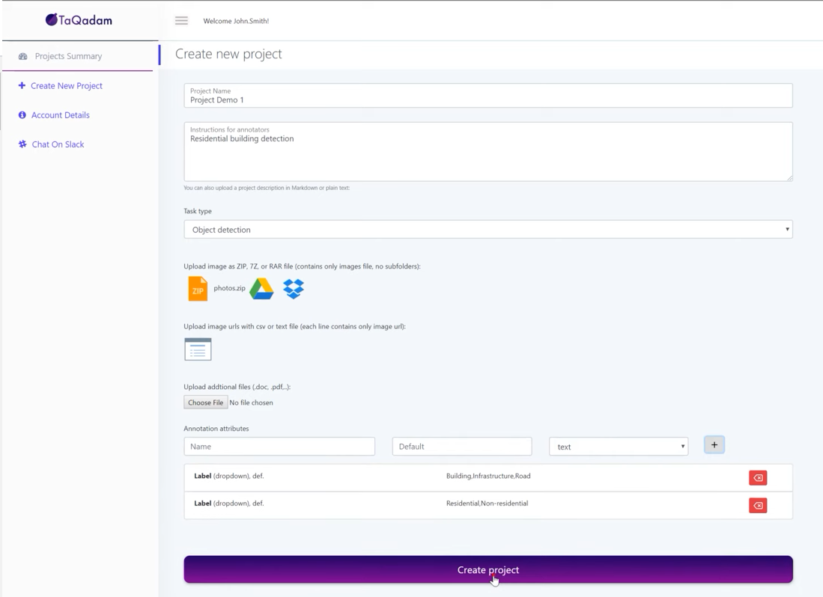

### **Pricing**

Very expensive

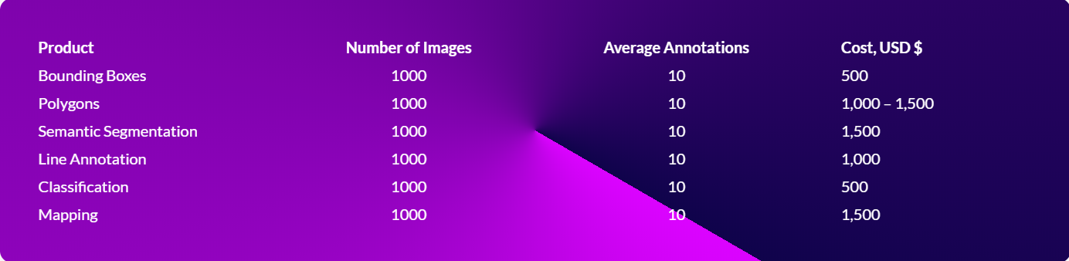

## **Labelbox**

### Description

Labelbox is collaborative training data software for computer vision teams.

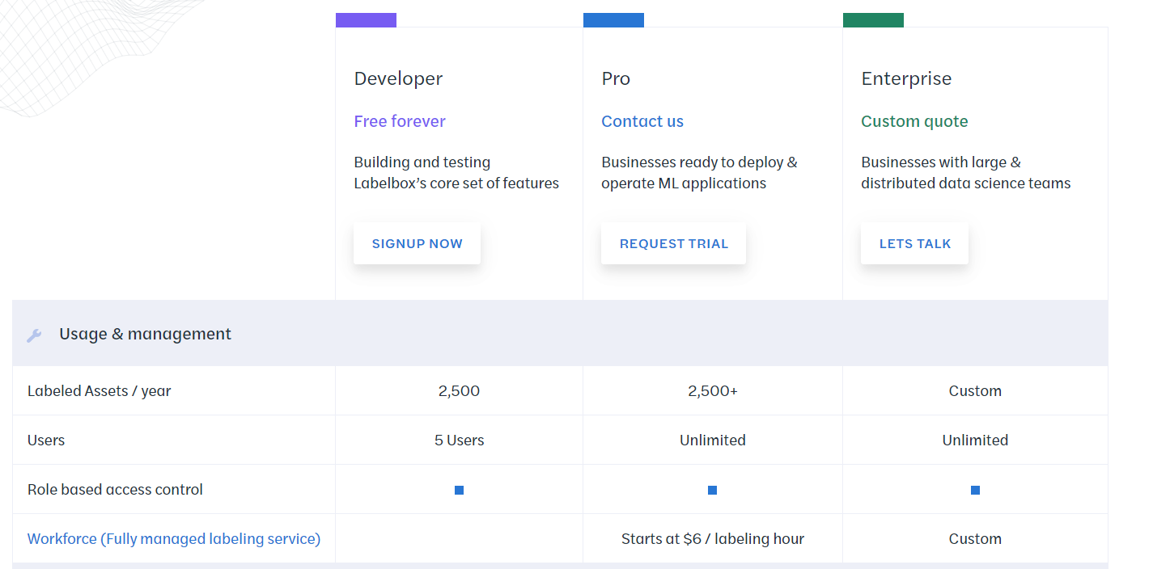

## Supahands (Malaysian company – located in Bangsar)

### Description:

We’re obsessed with giving AI companies **the best experience and quality.** Preparing training data is a crucial part of a Data Scientist and Machine Learning Engineer’s life. We act as your extended brain, doing the work on your behalf, exactly how you want it to be done.

**Supahands** focuses on preparing clean and accurate datasets at scale with our fully managed, fully handpicked SupaAgents. **We want to innovate the way people work** and provide high quality services to the world’s most game-changing companies.

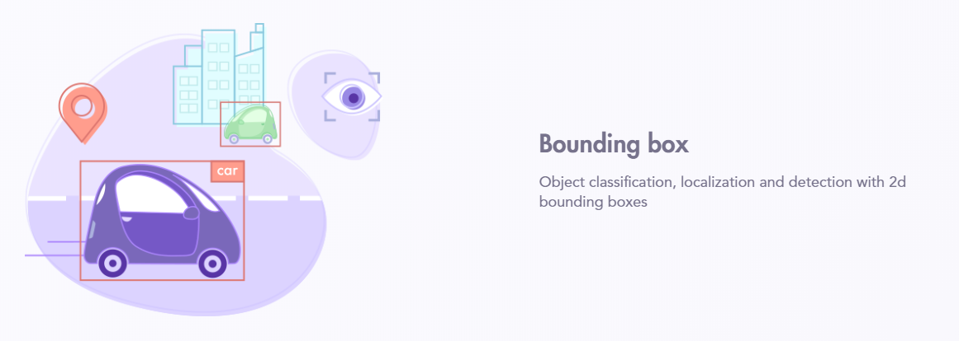

### Source:

<https://supahands.com/solutions/image-annotation/>

## Alegion

### Description:

Only Alegion provides a complete, full-service training data solution, with a true data annotation platform, a scalable trained workforce, and a team of ML project management experts.

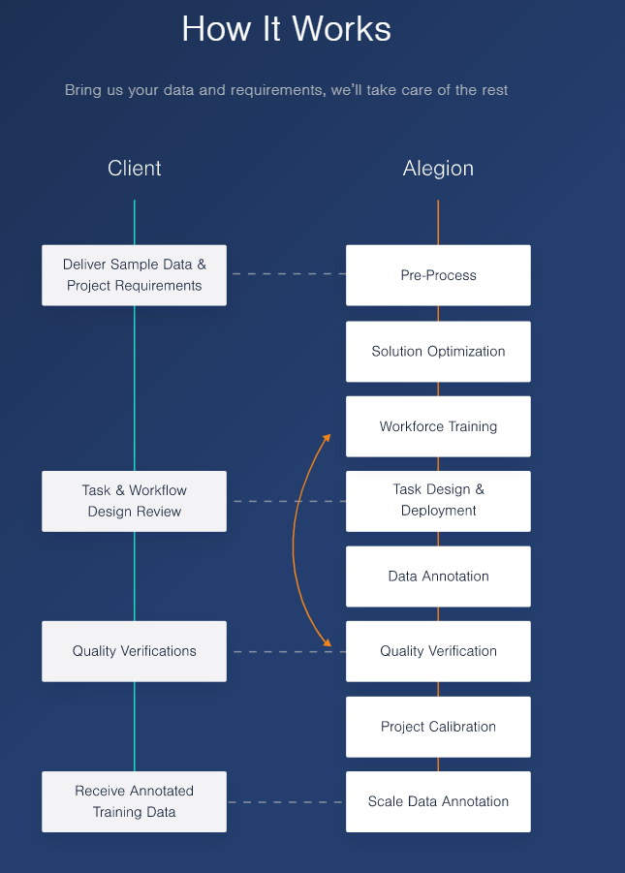

### Source: <https://www.alegion.com/why-alegion>

## Lionbridge

* Emailed, waiting for reply

### Description

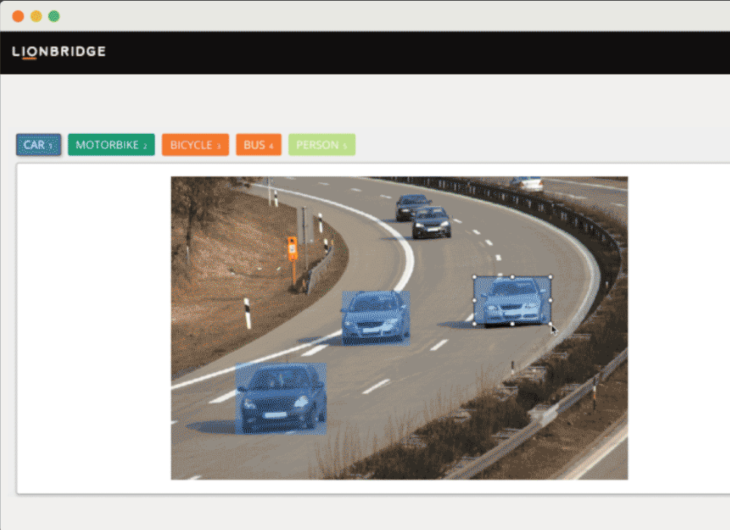

### Source: <https://lionbridge.ai/services/image-annotation/>

## Dataturks ([link](http://dataturks.com/features/image-bounding-box.php))

### Description

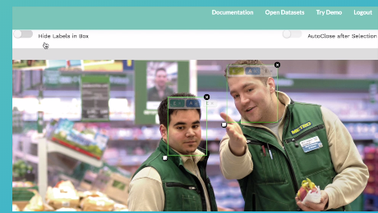

### Source: <http://dataturks.com/pricing.php>

Installation guide:

<https://medium.com/@dataturks/dataturks-on-prem-a-fully-self-hosted-data-annotation-solution-86b455bf0634>

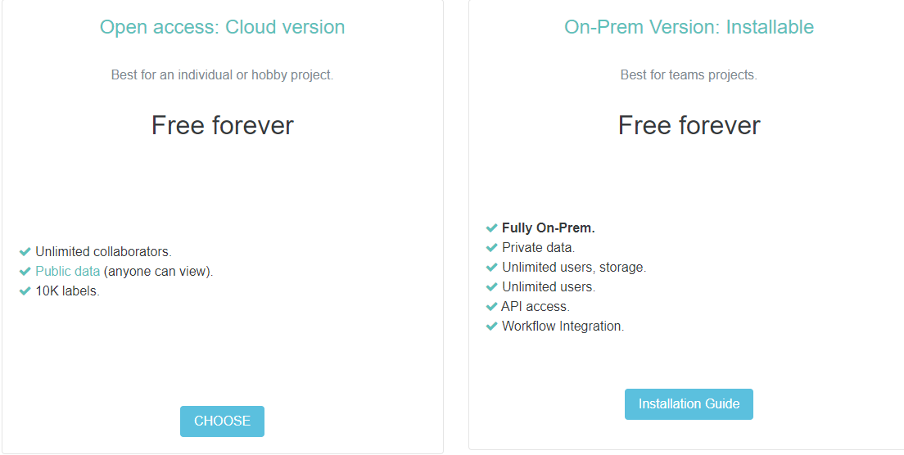

## Supervisely

* Emailed, waiting for reply
* 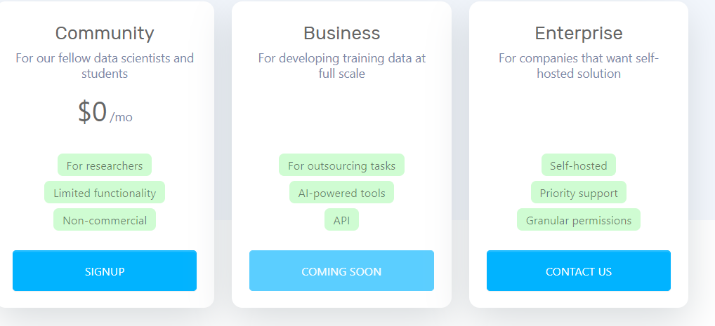

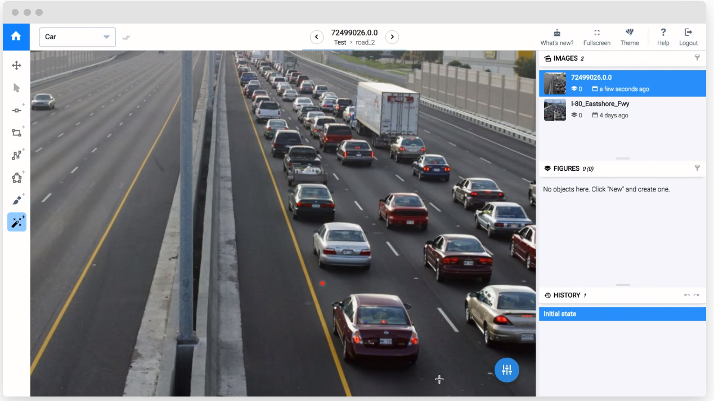

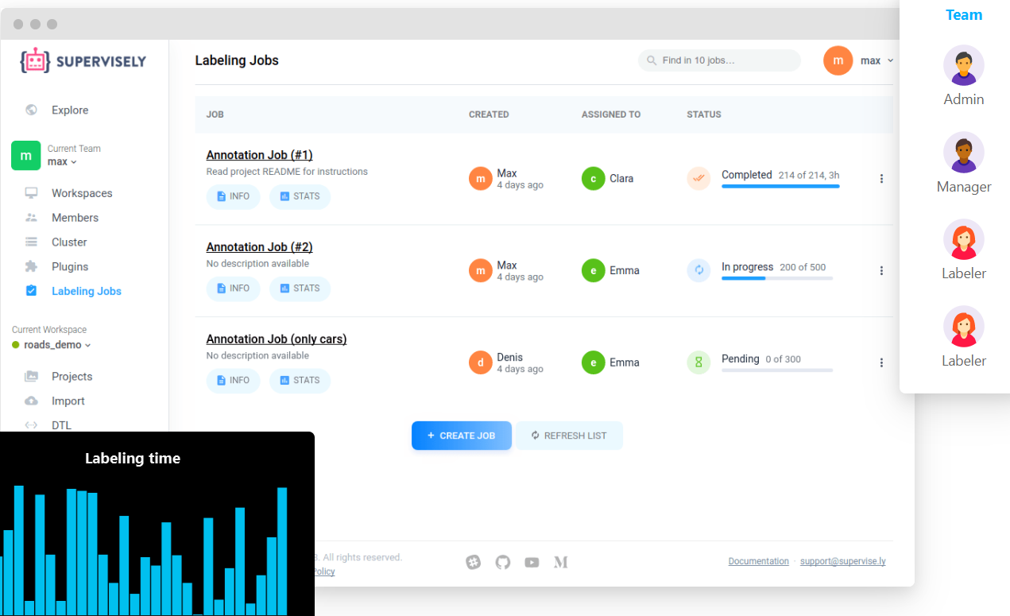

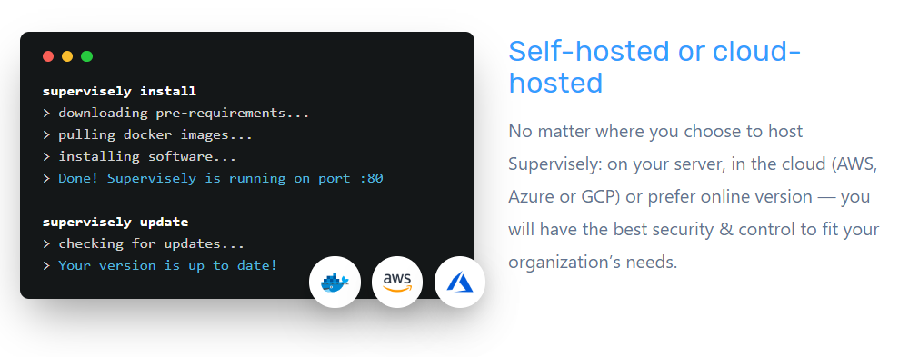

## Prodigy

* RM2000 per seat

**Per-seat license definition (google)**

A Per-**seat license** is a software **license** model based on the number of individual users who have access to a digital service or product. For example, 50-user per-**seat license would mean** that up to 50 individually named users can access the program (named user **licensing**).

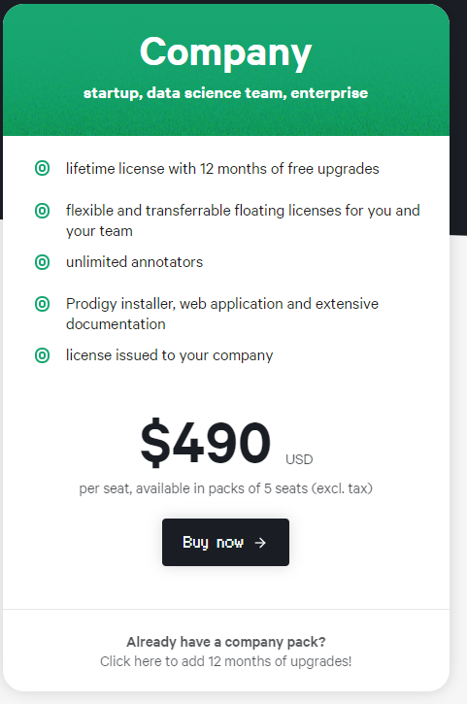

### Source: <https://prodi.gy/docs/api-database#setup-permissions> , <https://prodi.gy/>

## Super annotate

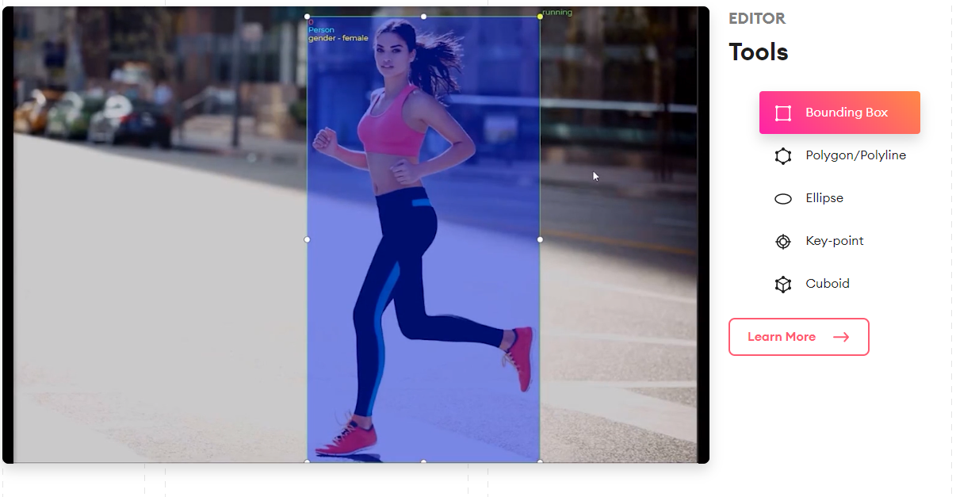

### Source: <https://www.superannotate.com/product>

### Pricing

<https://www.superannotate.com/pricing>

## Clarifai

### Source: <https://www.clarifai.com/label>

### Pricing:

Contact?

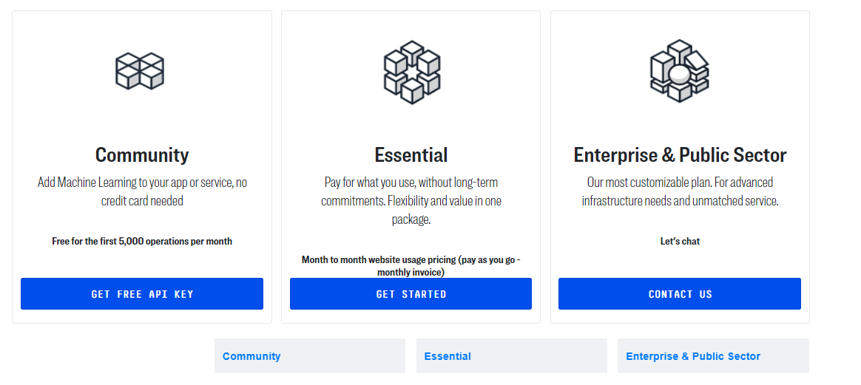

## Amazon Sagemaker Ground Truth

### Source: <https://aws.amazon.com/sagemaker/groundtruth/>

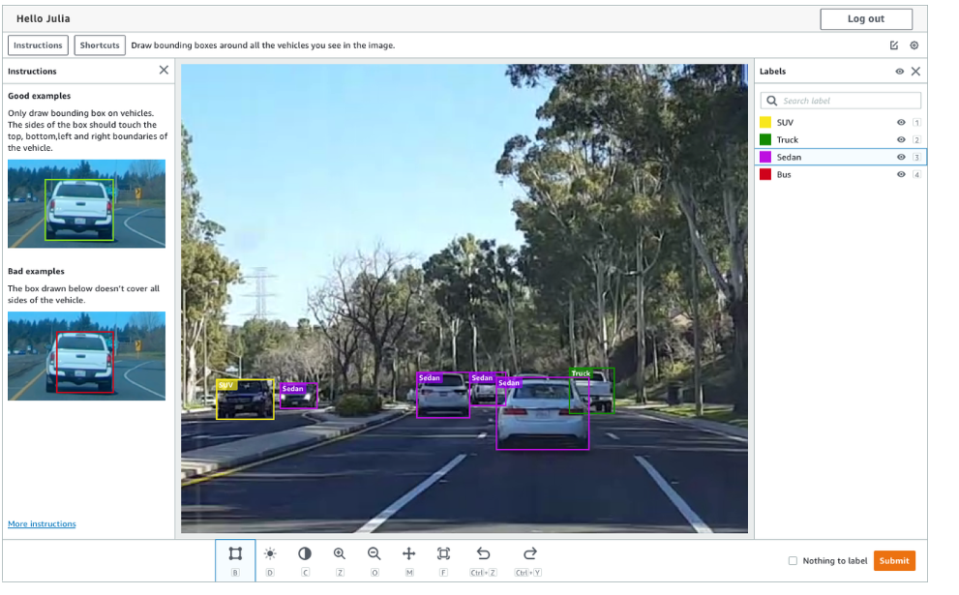

### Pricing:

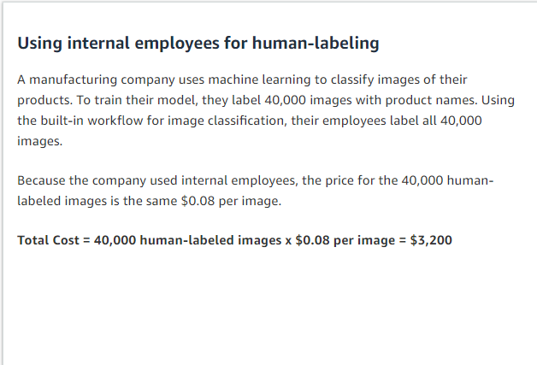

## Appen (not very clear)

Source: <https://appen.com/solutions/annotation-capabilities/>

Have to contact to ask about demo and pricing

## HIVE

### Source: <https://thehive.ai/hive-data>

### pricing:

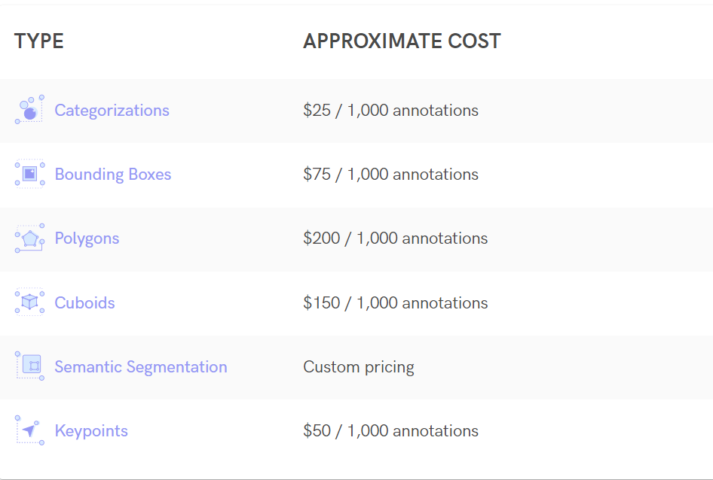

### DEMO: <https://thehive.ai/demo>

## PLAYMENT

### Source: <https://playment.io/gt-studio>

### Pricing: need to contact them

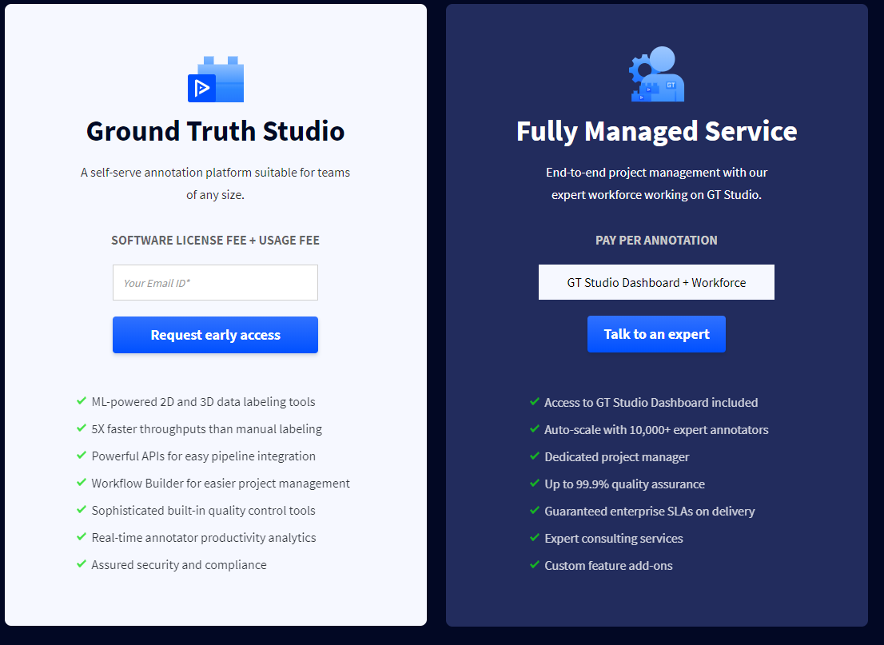

## V7 DARWIN

### Source: <https://www.v7labs.com/annotation>

Pricing: [https://www.v7labs.com/pricing](https://www.v7labs.com/pricing\)

## Cloud factory (not very clear on what theyre offering)

Source: <https://www.cloudfactory.com/what-we-offer/machine-learning>

Pricing: need to contact

## DATALOOP

### Source: <https://dataloop.ai/solutions/data-annotation/>

Have to request demo and contact them to ask about pricing

## TRAININGDATA.io

### Source: <https://www.trainingdata.io/>

### Pricing: have to contact them

## DIFFGRAM

### Source: <https://diffgram.com/>

### Pricing: <https://diffgram.com/pricing>

# Newly added

## <https://scale.com/>

## <https://www.superb-ai.com/> $9m funding

# Server based solutions

What are the **best** available labelling tools and server based solutions to streamline the process to make it easier for freelancers and surge.

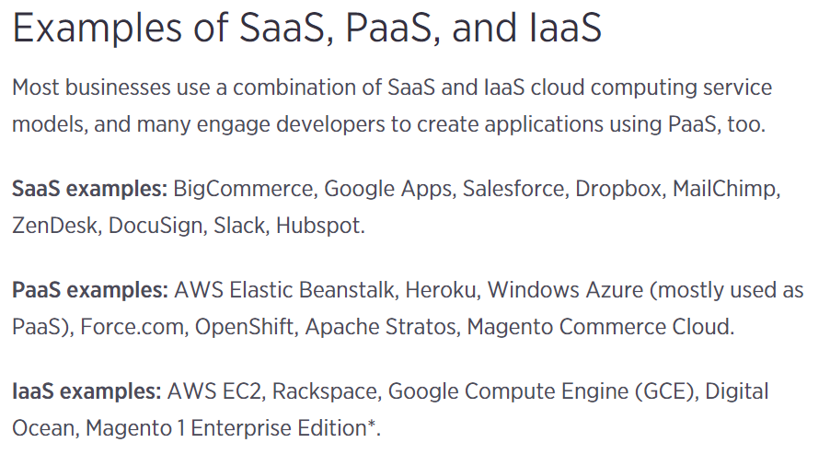

## **IAAS**

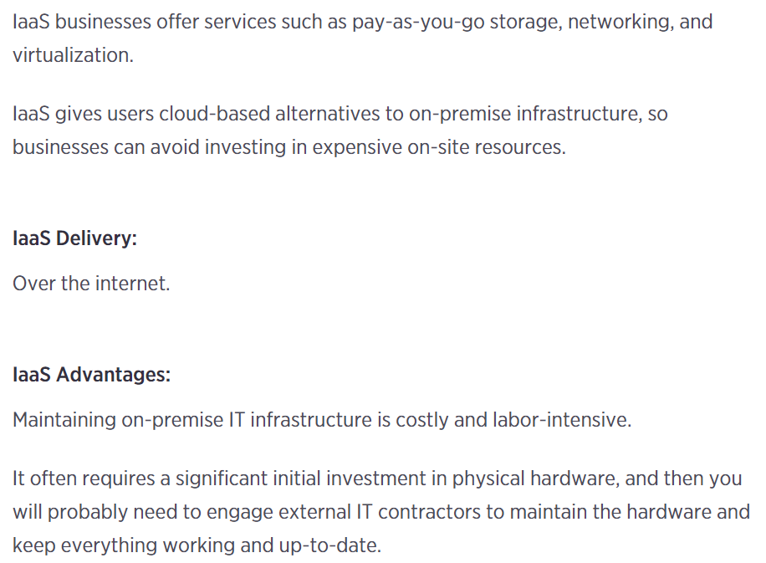

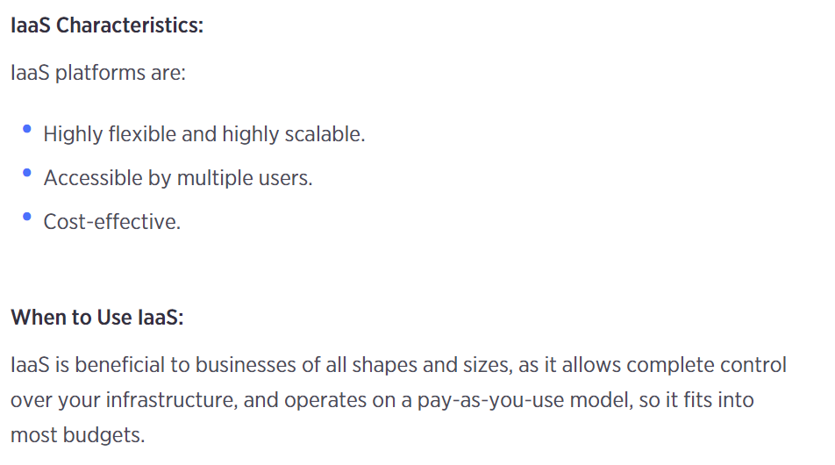

## **PAAS**

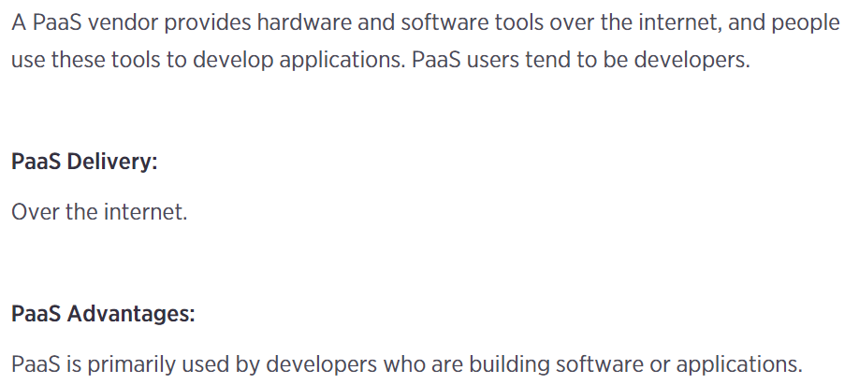

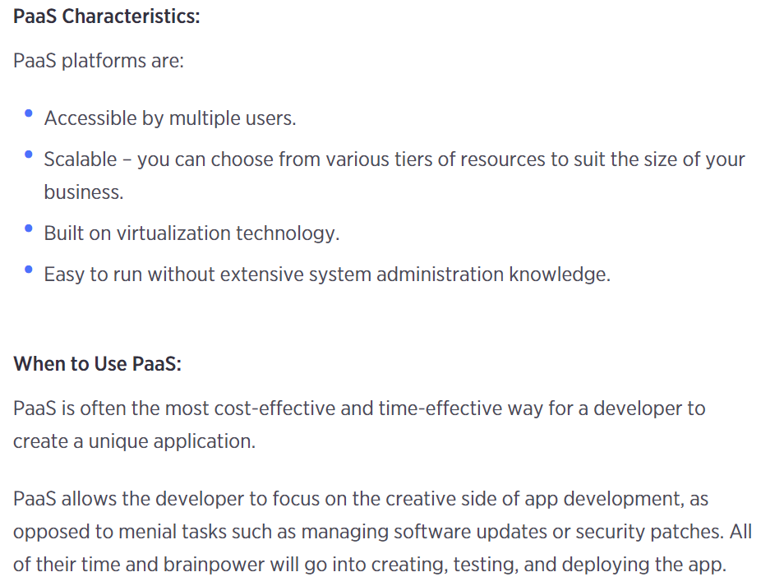

## **SAAS**

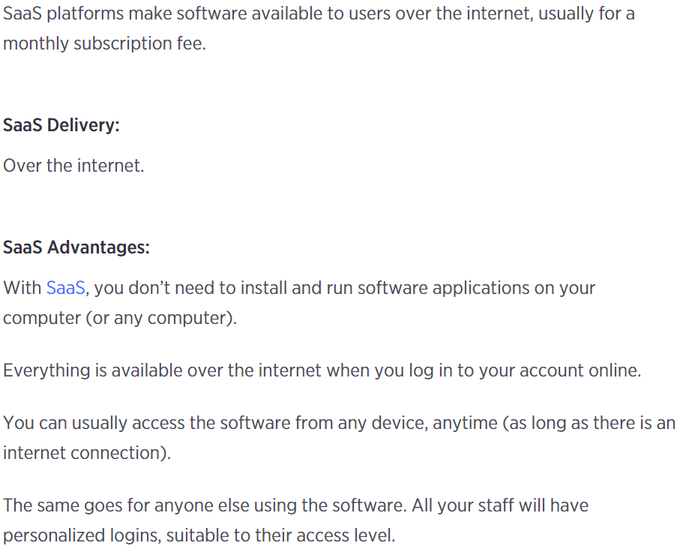

Differences between IAAS, PAAS and SAAS

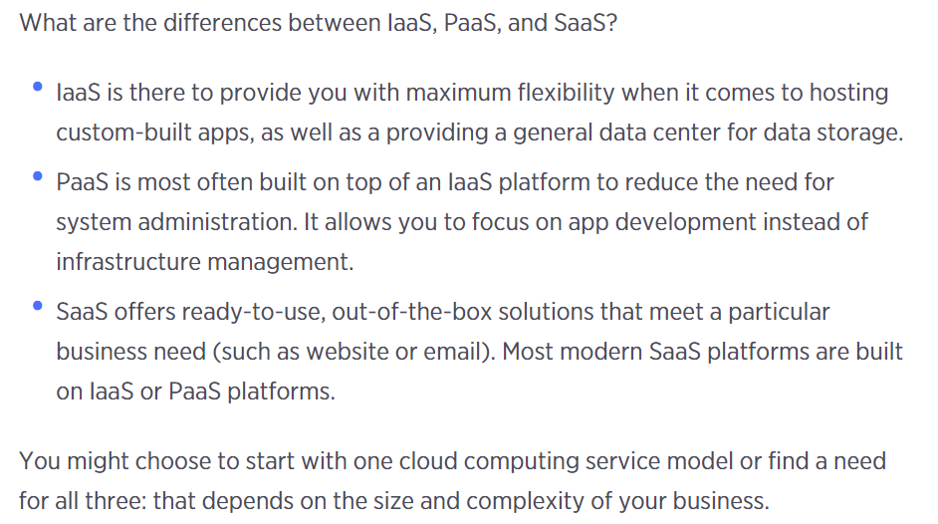

## What is Docker?

Advantages

* Container service
* VM (environment will be on docker)
* Pass the docker to another user

Disadvantages

* + GPU – not compatible – e.g. CUDA
  + Host site (complicated)